1. Shared the link and ask to solve below problem -   
     
   write a function to print output.  
   const arr = [2,3,5,6,7,8] – Was given  
   const target = 9   
   Output = [0,4] – Need to achieve this out put.
2. <https://www.geeksforgeeks.org/javascript-program-to-count-the-occurrences-of-each-character/>
3. let arr = [1, 2, 1, 3, 4, 2]  
     
    find out the element which has highest occurrence.   
   OP: 2  
     
    Min length array between highest occurrence element  
   OP:  [1, 2, 1]
4. Write code to print the 1. degree of an array  2. print the shortest sub array that led to this degree.  
   for example - 1, 2, 1,3,2 - degree -2 (max occurrence )  sub array - 1 is (1,2,1), and sub array for 2 is (2,1,3,2) . Shortest is for 1 as it has only 3 elements.
5. Given an array, write code to print unique number and the number of occurrences of each of the unique element.
6. There was an array of key value pair. Asked to reverse their positions.
7. Given a string `s` of length `n`. The task is to find the length of the shortest substring, which upon deletion, makes the resultant string to be consisting of distinct characters only.  
   A substring is a contiguous sequence of characters within a string. When a substring is deleted, one needs to merge the rest of the characters blocks of the string(s). If no substring needs to be deleted, the answer is 0.  
   Example 1:  
      Input - "xabbcacpqr"  
      Output - 3  
      Explanation - if we delete the substring in the range [3, 5], which is "bca", the resulting substring becomes "xabcpqr" in which all characters are distinct. This is the minimum length possible. Thus, the answer is 3.  
   Example 2:  
     Input - "abcbbk"  
      Output - 2  
      Explanation - if we delete the substring in the range [3, 4], which is "bb", the resulting substring becomes "abck" in which all characters are distinct. This is the minimum length possible. Thus, the answer is 2.
8. Given two strings s1 and s2, let us assume that while typing the strings there were some backspaces encountered which are represented by #. The task is to determine whether the resultant strings after processing the backspace character would be equal or not.  
    Example:   
      Input: s1= geee#e#ks, s2 = gee##eeks   
      Output: True   
      Explanation: Both the strings after processing the backspace character becomes “geeks”. Hence, true.  
     
   [Check if two strings after processing backspace character are equal or not - GeeksforGeeks](https://www.geeksforgeeks.org/check-if-two-strings-after-processing-backspace-character-are-equal-or-not/)
9. 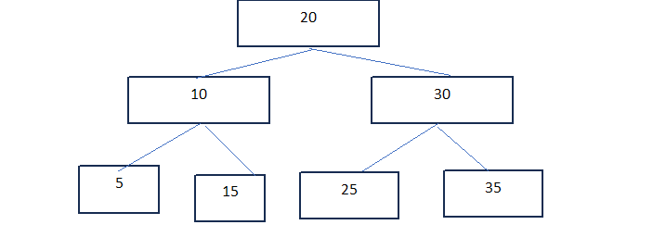  
   Search the array of numbers (30,10,12,35) in the binary tree and print 1 if present and 0 if not present. The output should be (1,1,0,1)
10. Search a given  string and return the position of first distinct ( after removing duplicates) character . If no distinct character , return -1

For example - falafal  - no unique = -1, hackathon = 3 since C is the first distinct character and its position is 3 on 1-index 

1. string  ( yy, u, oe);   Query ( 1-2, 2-3) 1-2 means search the array of string from position 1 to position2 and return the count of strings that start with a vowel and end with Vowel - you didnt add this question to the blueprint
2. You are given the input string, you need to find the unique character from the input string and return the position of the first occurrence of the unique character if there is no unique character then return -1.   
   let suppose you are given input as "hackthat" here unique character is ["c", "k"] now you have to return the position of the first unique character here "c" is in the 3rd position so return 3.  
   another input as "lalala" here we can see no unique character present in this input string so return -1 in this case